Total amount spent by each customer

**Code Snippet**:



**Output** :

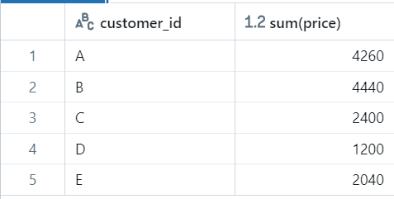

**Visualization :**

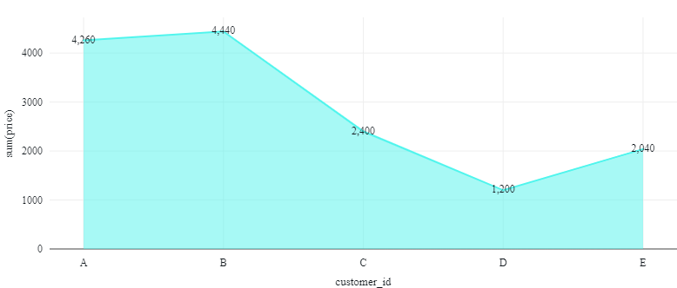

**Total Amount Spent by Each Food Category**

**Code Snippet**:



**Output** :

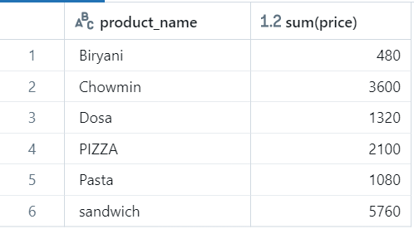

**Visualization:**

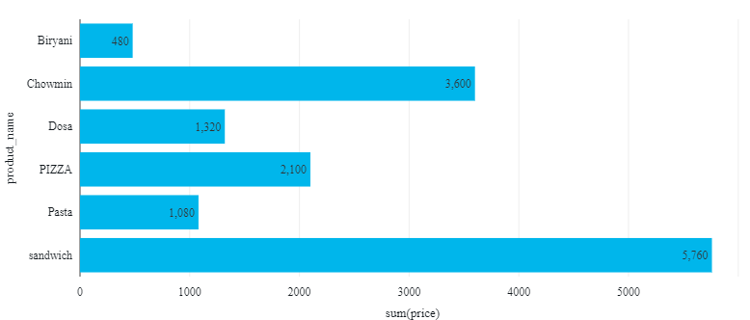

### **Total Sales by Month**

**Code Snippet**:

**Output** :

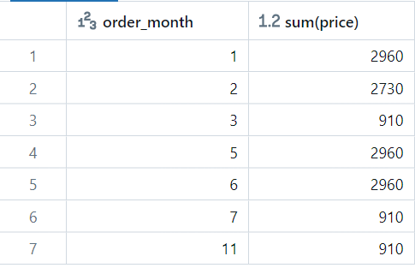

**Visualization:**

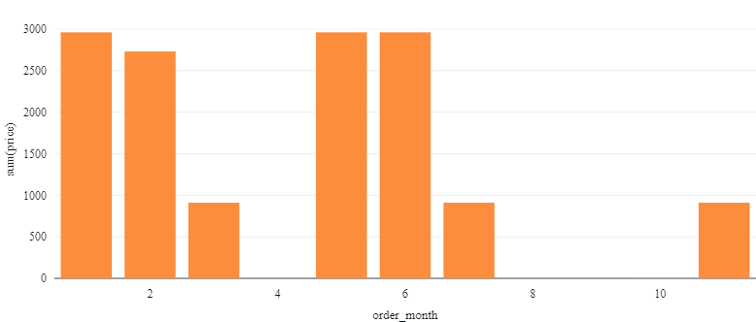

### **4. Yearly Sales**

**Code Snippet**:



**Output (Yearly Sales Example)**:

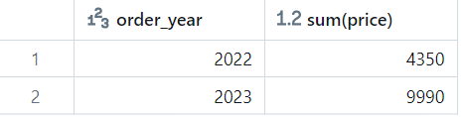

**Visualization:**

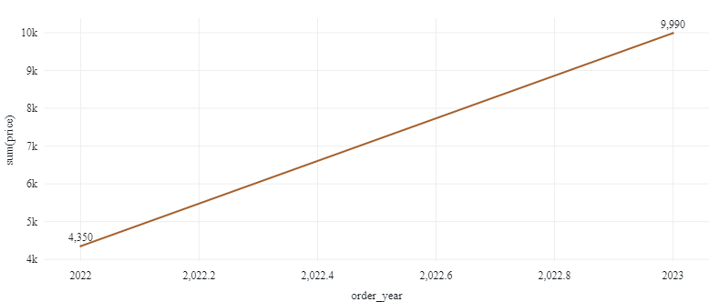

### **5. Total Number of Orders by Each Category**

**Code Snippet**:

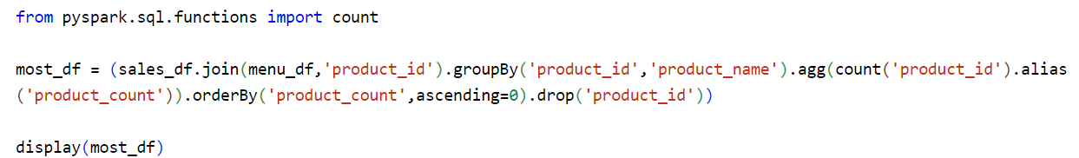

**Output** :

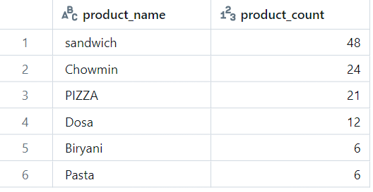

**Visualization:**

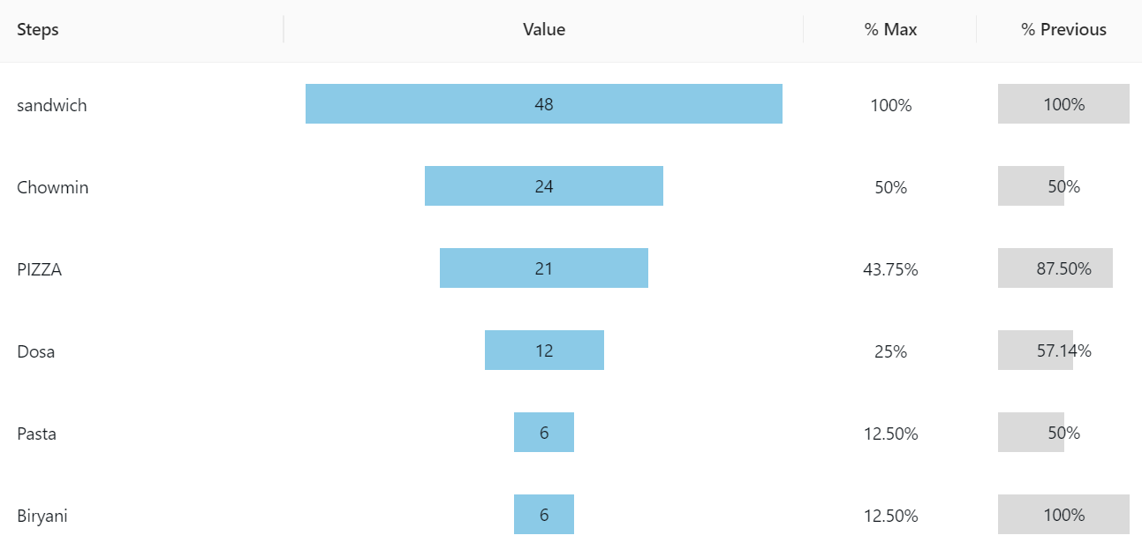

### **6. Total Sales by Order Source**

**Code Snippet**:

**Output** :

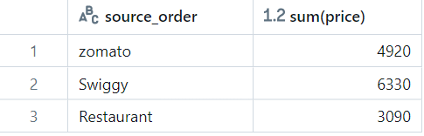

**Visualization:**

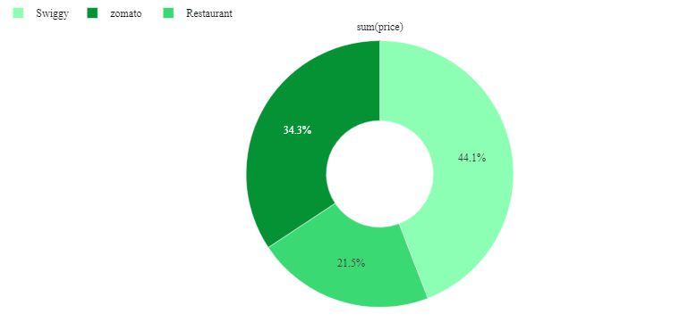

### **7. Frequency of Customer Visits**

**Code Snippet**:

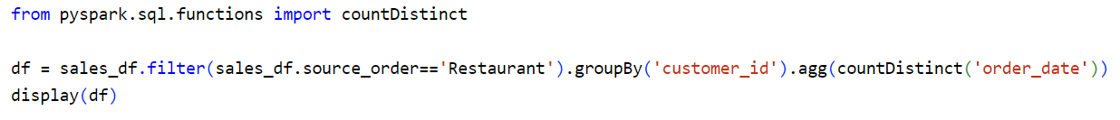**Output** :

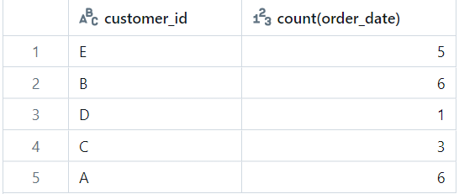

**Visualization:**

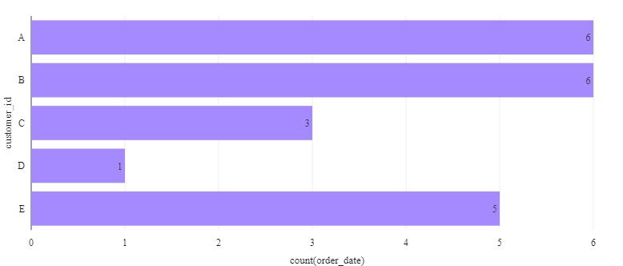

**8. Quarterly Sales**

**Code Snippet**



**Output**

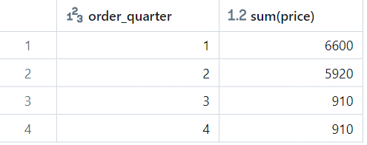

**Visualization:**

